Wellpath Team Members and Contract Workers are expected to  CLOCK IN / CLOCK OUT  when reporting to / leaving from work and for unpaid breaks.  How To Clock In / Clock Out:  - Hold your ID badge so your picture is facing you and the barcode runs along the left side. | 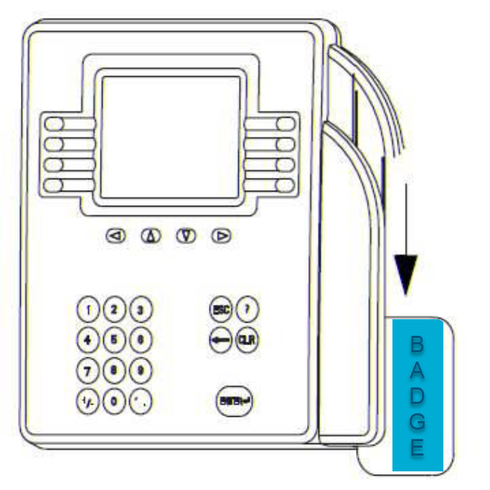
- Position the badge into the black magnetic reader block on the right side of the timeclock faceplate.
- In one steady motion, slide your badge down through the magnetic reader block.

How Do I Know If My Swipe Is Accepted?

- You will hear only 1 beep from the timeclock. The top light on the timeclock will turn green.

How Do I Know If My Swipe Is Not Accepted?

- An Error message will appear on the display panel.
- You will hear a series of 3 beeps.
- The middle light on the timeclock will turn red.
- Try to swipe again: if your swipe is not accepted, note the error message and report it to your Manager to ensure that your time is entered into the system for accurate payroll.
What Happens If I Do Not Clock In / Clock Out?  A team member or contract worker who fails to utilize  Kronos to record their work hours*… | Action
first occasion (1 occurrence) |  | Written Verbal Coaching
two occasions (including two entries on the same shift) (2 occurrences) |  | Written Corrective Action
third occasion (including two entries on the same shift) (3 occurrences) |  | Final Corrective Action
fourth occasion (including two entries on the same shift) (4 occurrences) |  | Termination or Cancellation  of Contracted Services
# of Occurrences in a Six (“6”) Month Period*

